3.3 Guided Practice: React Integration

Christopher Crayton
ECPI University
SDC360: Web Application Development
Mohammad Zakaria
March 22, 2026

3.3 Guided Practice: React Integration
Original Code Display:
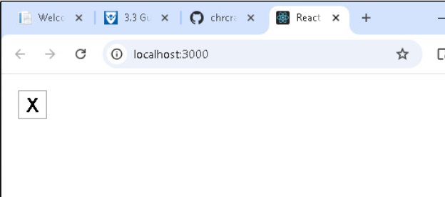
Updated Code:
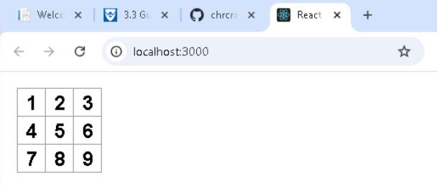
Functionality Added:
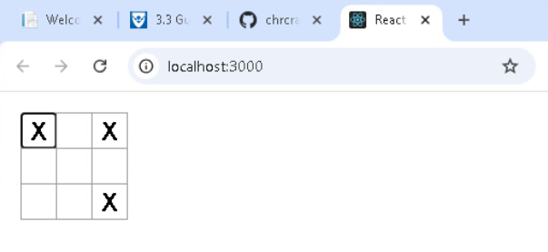
Winner X Display:
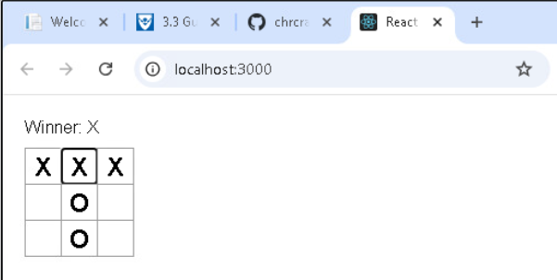
Winner O Display:
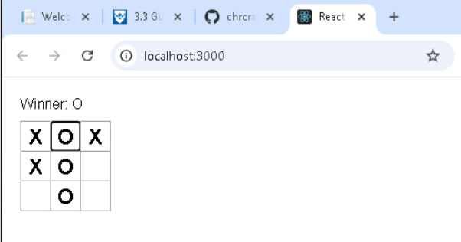
Draw Display:
